

**Sensor-Driven Asthma Detection Using Machine Learning for Real-Time Health Monitoring**

*A Minor Project Report (21EC )*

**Submitted by,**

**Mohammed Asim 1RV21EC099**

**Mohammad Saifali Shaikh 1RV22EC410**

**Sandeep RC 1RV22EC413**

**Sathish V 1RV22EC414**

**Under the guidance of**

**Dr. Usha Rani** Professor

Dept. of ECE

RV College of Engineering

**In partial fulfillment of the requirements for the degree of Bachelor of Engineering in**

**Electronics and Communication Engineering 2024-25**



**RV College of Engineering**®**, Bengaluru**

(*Autonomous institution affiliated to VTU, Belagavi*) **Department of Electronics and Communication Engineering**

.

##### CERTIFICATE

Certified that the minor project (21EC177) work titled ***Sensor- driven asthma detection using machine learning for real time health monitoring*** is carried out by **Mohammed Asim** (**1RV21EC099**), **Mohammad Saifali Shaikh (1RV22EC410), Sandeep R C(1RV22EC413), Sathish V (1RV22EC414)** who is bonafide student of RV College of Engineering, Bengaluru, in partial fulfilment of the requirements for the degree of **Bachelor of Engineering** in **Electronics and Communication Engineering** of the Visvesvaraya Technological University, Belagavi during the year 2024-25. It is certified that all corrections/suggestions indicated for the Internal Assessment have been incorporated in the minor project report deposited in the departmental library. The minor project report has been approved as it satisfies the academic requirements in respect of minor project work prescribed by the institution for the said degree.

Guide Head of the Department Principal

Dr. Usha Rani Dr. H V Ravish Aradhya Dr. K. N. Subramanya

**External Viva**

Name of Examiners Signature with Date

1.

2.

##### DECLARATION

I, **Mohammed Asim, Mohammad Saifali Shaikh, Sandeep R C, Sathish V** student of seventh semester B.E., Department of Electronics and Communication Engineering, RV College of Engineering, Bengaluru, hereby declare that the internship project titled ‘**Sensor- driven asthma detection using machine learning for real time health monitoring**’ has been carried out by me and submitted in partial fulfilment for the award of degree of **Bachelor of Engineering** in **Electronics and Communication Engineering** during the year 2024-25.

Further I declare that the content of the dissertation has not been submitted previously by anybody for the award of any degree or diploma to any other university.

I also declare that any Intellectual Property Rights generated out of this project carried out at RVCE will be the property of RV College of Engineering, Bengaluru and we will be one of the authors of the same.

Place: Bengaluru

Date:

Name Signature

1. Mohammed Asim (1RV21EC099)
2. Mohammad Saifali Shaikh (1RV22EC410)
3. Sandeep R C (1RV22EC413)
4. Sathish V (1RV22EC414)

##### ACKNOWLEDGEMENTS

I am indebted to my guide, **Dr. Usha Rani**, Assistant Professor, RV College of Engineering*.* for the wholehearted support, suggestions and invaluable advice throughout my project work and also helped in the preparation of this thesis.

My sincere thanks to **Dr. H V Ravish Aradhya**, Professor and Head, Department of Electronics and Communication Engineering, RVCE for the support and encouragement.

I express sincere gratitude to our beloved Principal, **Dr. K. N. Subramanya** for the appreciation towards this project work.

I thank all the teaching staff and technical staff of Electronics and Communication Engineering department, RVCE for their help.

Lastly, I take this opportunity to thank my family members and friends who provided all the backup support throughout the project work.





##### ABSTRACT

This project integrates an ESP32 microcontroller with multiple sensors to create an advanced system for the detection and prediction of asthma. At its core is the MEMS INMP441 microphone, placed on the chest to capture respiratory sounds, identifying abnormalities such as wheezing or crackles, key indicators of asthma. Complementing this, environmental sensors measure air quality (PM2.5 and PM10), temperature, and humidity, all of which are known triggers for asthma symptoms. Physiological parameters such as heart rate (BPM) and oxygen saturation (SpO2) are also monitored to provide a complete health assessment. An RTOS-based architecture ensures efficient real-time data processing, enabling the ESP32 to handle multiple inputs seamlessly. Preprocessed data, including noise-reduced and feature-enhanced signals, are used to train a machine learning model on the Edge Impulse platform. This model predicts asthma risk levels based on multidimensional sensor data, providing timely and accurate results. The results are displayed on an 1.3 inch OLED screen for easy user interpretation, while a buzzer delivers alerts in critical conditions, ensuring rapid response when necessary. This system offers a transformative solution for asthma management by combining real-time monitoring with predictive analytics. It is particularly valuable for early diagnosis and proactive care, especially in low-resource settings, paving the way for more accessible and efficient health management.

(i)

**CONTENTS**

**Abstract…** **i**

**List of Figures iv**

**Abbreviations…** **v**

**Chapter 1 1**

Profile of the Organization 2

* 1. RV College of Engineering 2
  2. COE In Connected Autonomous Vehicle 2

**Chapter 2 4**

Activities of the Organization 5

* 1. COE in Autonomous and connected vehicles 5
  2. Interdisciplinary Research and Innovation 6
  3. Area of work and collaboration 6
  4. Current project 6

**Chapter 3 8**

Tasks Performed 9

* 1. Task1: Introduction to Robot Operating System (ROS) 9
     1. Computation graph model 10
     2. ROS Tools 13
  2. Task2: Fundamentals of LiDAR SLAM techniques 14
     1. Linux 15
     2. Livox ROS Driver 15
     3. Xsens ROS Driver 15
     4. K-Dimensional Tree 15
     5. Loop Closure Detection 16
     6. Georgia Tech Smoothing and Mapping (GTSAM) 16
     7. Pose Graph Optimization 16
     8. Simultaneous Localization & Mapping (SLAM) 16
     9. LiDAR Inertial Odometry (LIO) 16
     10. Scan Context-based Mapping 16
     11. LiDAR Odometry 17
  3. Task 3: Overview of components 17
  4. Task 4: Steps For Implementation 19

**Chapter 4 23**

Reflections 24

* 1. Results 24
  2. Learning Outcomes 26

**Bibliography 28**

### LIST OF FIGURES

|  |  |
| --- | --- |
| 1.1 | About the organization 3 |
| 2.1 | Logo of IISC 5 |
| 2.2 | Logo of WIPRO 6 |
| 2.3 | Projects in WIRIN Lab 7 |
| 2.4 | LiDAR mounted on car for testing in WIRIN Lab 7 |
| 3.1 | ROS Computational Graph Level 12 |
| 3.2 | ROS Computational Graph of 2 nodes communicating with each other 12 |
| 3.3 | RPlidar 17 |
| 3.4 | IMU6050 18 |
| 3.5 | Odomentry 18 |
| 3.6 | Design flow of Slam Integration… 19 |
| 3.7 | Cloning FAST-LIO 2 & SC-PGO node into the workspace 20 |
| 3.8 | Building the sourced packages inside workspace 20 |
| 3.9 | Running roslaunch command for FAST-LIO2 21 |
| 4.1 | Hector Slam 24 |
| 4.2 | Working of Project 25 |
| 4.3 | Final Project 26 |

### ABBREVIATIONS

**ESP -** Espressif Systems

**MEMS -** Micro-Electro-Mechanical Systems

**INMP-** InvenSense High Precision Omnidirectional Microphone Module

**PM -** particulate matter

**BPM –** Beats per minute

**SpO2 -** Oxygen saturation

**OLED -** Organic Light Emitting Diode

**RTOS -** Real-Time Operating System

**IoT** **-** Internet of things

# Chapter 1

## Introduction to Asthma

### CHAPTER 1

#### INTRODUCTION TO ASTHMA

**1.1 Introduction**

Asthma is a chronic respiratory condition characterized by inflammation and narrowing of the airways, leading to symptoms such as wheezing, shortness of breath, and coughing. Conventional methods of asthma diagnosis often rely on spirometry tests, patient-reported symptoms, and physical examinations. However, these approaches may be subject to variability in results and depend heavily on the expertise of healthcare professionals. Undiagnosed or misdiagnosed cases can lead to exacerbated health complications, making early and accurate detection crucial for effective management and treatment.

This project aims to address the limitations of traditional asthma diagnostic methods by leveraging machine learning (ML) technologies. It seeks to enhance the accuracy and efficiency of asthma detection through the analysis of complex datasets, including lung function measurements, environmental factors, and patient histories. By utilizing advanced ML models, the project aims to automate the process, offering real-time predictions and reducing reliance on conventional diagnostic tools. The system will provide objective, reliable, and accessible asthma risk assessments, ultimately improving healthcare delivery for asthma patients

.

The future scope of this project lies in its potential to transform asthma detection and management on a broader scale. As the system evolves, it could integrate more personalized data such as genetic markers and lifestyle factors, enabling even more accurate predictions. Additionally, with advancements in IoT technologies and mobile applications, this approach could be expanded to continuously monitor patients in real-time, providing immediate alerts to patients and healthcare providers about potential asthma exacerbations. Over time, this could lead to better patient outcomes, more personalized treatment plans, and greater accessibility to healthcare, especially in underserved areas.

**1.2 Motivation**

The motivation for exploring asthma detection using machine learning stems from the growing global burden of asthma, which affects millions of individuals and often remains underdiagnosed or misdiagnosed, particularly in underserved populations. Traditional diagnostic methods can be time-consuming, resource-intensive, and reliant on subjective assessments, leading to delayed treatment and poor health outcomes. Machine learning offers an innovative approach to address these challenges by leveraging vast amounts of clinical, environmental, and physiological data to provide accurate and timely asthma predictions. This technology has the potential to revolutionize asthma care by enabling early intervention, personalized treatment plans, and broader access to diagnostic tools, ultimately improving patient outcomes and reducing healthcare costs.

**1.3 Problem Statement**

To design a portable and affordable diagnostic system for asthma with continuous monitoring, timely diagnosis, effective management, especially in low-resource settings.

**1.4 Objectives**

* Develop a Real-Time Respiratory Monitoring System using the INMP441 microphone to detect abnormalities like wheezing. `
* Integrate Multi-Sensor Data Collection for gas levels, temperature, humidity, heart rate, and SpO₂.
* Implement RTOS to efficiently manage data acquisition, sound processing, and display updates.
* Train and Deploy a Machine Learning Model on ESP32 for real-time asthma detection using Edge Impulse.
* Enable Real-Time Alerts via a buzzer and OLED display for abnormal respiratory patterns or environmental triggers.
* Design an Intuitive Display Interface for real-time vitals and asthma status.
* Establish Data Forwarding to Edge Impulse for continuous model refinement.

# Chapter 2

## Methodology

### CHAPTER 2

#### METHODOLOGY

###### 2.1 System Design and Sensor Integration

• The INMP441 microphone is interfaced with the ESP32 microcontroller to capture respiratory sounds continuously with high fidelity, ensuring accurate detection of subtle respiratory anomalies such as wheezing, crackles, and other abnormal lung sounds. The microphone's digital output minimizes noise interference, providing clean audio signals for precise analysis. Figure 2.1 shows the circuit diagram of the project.

• Additional sensors, including CO2 gas sensors, temperature and humidity sensors, pulse oximeters for SpO2, and heart rate monitors, are integrated to collect comprehensive real-time physiological and environmental data. These sensors work in tandem to provide a holistic view of the patient's respiratory health and environmental conditions that may trigger asthma symptoms.

• All sensor data is synchronized using a Real-Time Operating System (RTOS) to manage multiple tasks efficiently, ensuring that data from different sources are accurately timestamped and processed concurrently without loss of fidelity. This synchronization allows for real-time correlation of respiratory sounds with environmental and physiological parameters, enhancing the system's diagnostic accuracy.

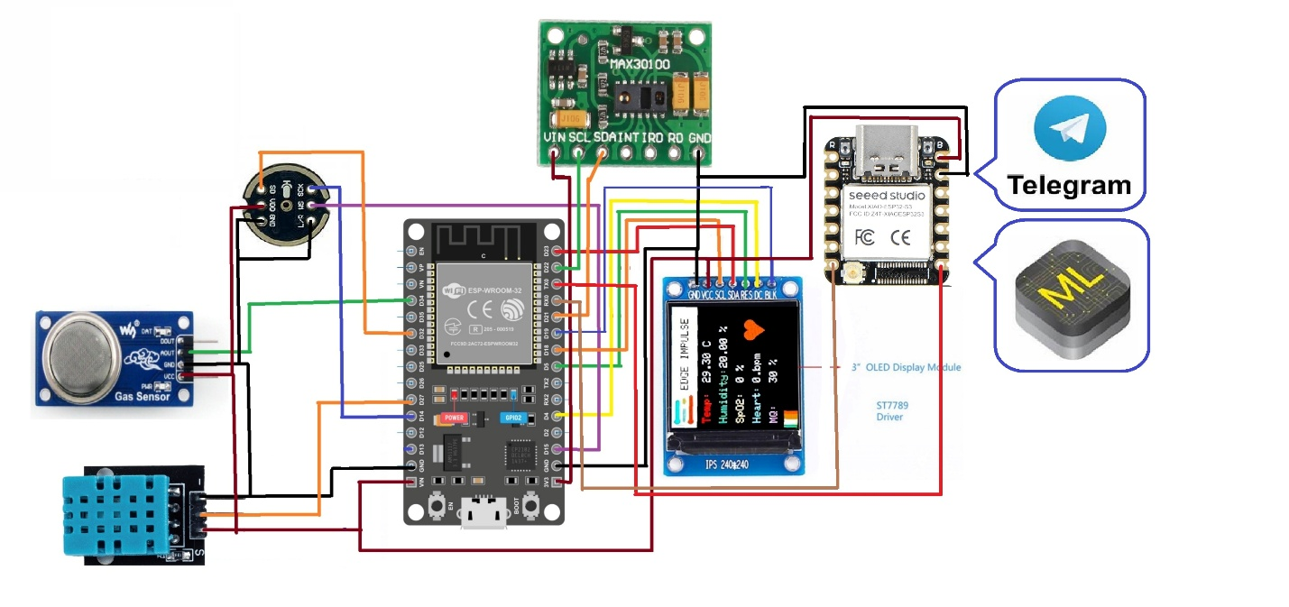

Figure 2.1: Circuit Diagram

**2.2 Real-Time Operating System (RTOS) Implementation**

• RTOS is utilized to prioritize high-priority tasks like respiratory monitoring while ensuring smooth execution of other tasks such as data logging, wireless communication, and display updates, thereby maintaining system stability and performance. The RTOS architecture supports multitasking, enabling the system to handle complex operations without compromising responsiveness.

• Different tasks are scheduled using RTOS task management, leveraging priority-based scheduling and interrupt-driven execution for time-sensitive operations, such as immediate response to abnormal respiratory events. This ensures that critical health alerts are processed and communicated promptly, providing timely interventions to prevent asthma exacerbations.

**2.3 Data Processing and Feature Extraction**

• The microphone data undergoes preprocessing, including noise filtering using digital signal processing techniques, and segmentation into relevant time windows to extract meaningful respiratory patterns. Advanced filtering algorithms are employed to remove background noise and enhance the clarity of respiratory sounds.

• Key audio features such as frequency variations, amplitude changes, and specific wheezing detection patterns are extracted using algorithms like Fast Fourier Transform (FFT) and wavelet transforms. These features are critical for distinguishing between normal and abnormal breathing sounds, enabling accurate asthma detection.

• Environmental parameters (temperature, humidity, and gas levels) are correlated with respiratory data for comprehensive analysis, enabling context-aware detection of asthma triggers and exacerbations. This multi-dimensional analysis helps in identifying patterns and trends that contribute to asthma symptoms, facilitating proactive management.

**2.4 Machine Learning Model Development**

• Collected respiratory and environmental data is forwarded to the Edge Impulse platform for training an AI-based model, utilizing robust datasets to enhance model generalization and accuracy. The platform's tools for data visualization and model training streamline the development process, ensuring high-quality models.

• Feature engineering and dataset labelling are meticulously performed to classify normal and abnormal breathing patterns, ensuring high sensitivity and specificity in asthma detection. Expert knowledge is incorporated in the labelling process to enhance the reliability of the training data.

• A trained ML model is optimized through techniques like quantization and pruning, and then deployed on the ESP32 microcontroller for real-time asthma detection with minimal latency and power consumption. These optimizations ensure that the model runs efficiently on resource-constrained devices, making the system portable and energy-efficient.

**2.5 Real-Time Prediction and Alert Mechanism**

• The deployed ML model continuously analyses incoming respiratory and environmental data, providing instantaneous feedback on the user’s respiratory health status. The system is designed to detect even subtle changes in breathing patterns, enabling early identification of potential asthma attacks.

• If abnormal breathing patterns or environmental triggers are detected, the system activates a buzzer for audible alerts and displays a warning message on the OLED screen, ensuring timely intervention and user awareness. The alert mechanism is customizable, allowing users to set thresholds and preferences for notifications.

**2.6 Display Interface for User Interaction**

• An OLED screen is used to display real-time sensor readings, respiratory status, and asthma detection results in a clear and concise manner. The display provides continuous updates, ensuring that users have access to the latest health information at all times.

• The interface is designed to be intuitive, featuring graphical representations and color-coded alerts to enable easy interpretation of health parameters, even for non-technical users. User-friendly navigation and visual cues enhance the overall usability of the system.

**2.7 Data Forwarding for Model Improvement**

• The ESP32 is connected to Edge Impulse via Wi-Fi or Bluetooth for continuous data logging and model refinement, ensuring that the system evolves with new data inputs. This connectivity allows for seamless updates and improvements to the ML model based on real-world usage.

• New data is uploaded periodically to improve the accuracy of asthma detection models through retraining, enabling the system to adapt to individual user profiles and changing environmental conditions. This continuous learning approach ensures that the system remains effective and relevant over time, providing personalized healthcare solutions.

# Chapter 3

## Results and discussion

**Chapter 3**

RESULTS AND DISCUSSION

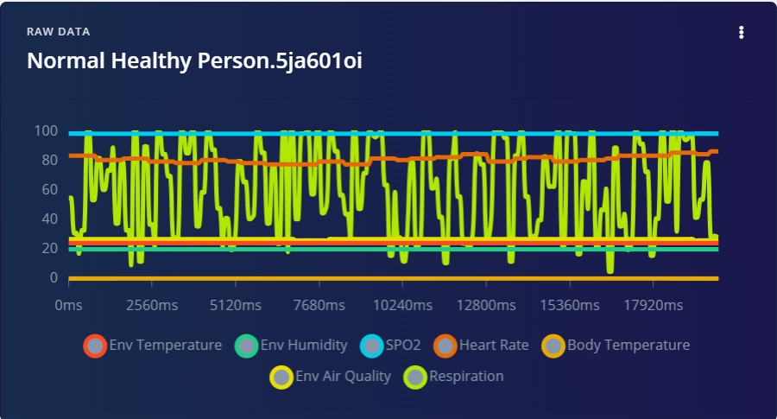

Fig. Asthma Patient’s normal condition readings

Fig. the provided graph displays physiological and environmental parameter readings for an individual under normal conditions. The parameters measured include environmental temperature, humidity, air quality, SPO2 (oxygen saturation), heart rate, body temperature, and respiration. Each parameter is represented using distinct colors, with values plotted over time in milliseconds. The stable trends of heart rate (orange line) and SPO2 (cyan line) suggest normal cardiovascular and oxygen saturation levels, while respiration (yellow-green) shows significant fluctuations, indicating natural variability in breathing patterns. The environmental parameters, such as temperature (red line) and humidity (green line), remain relatively stable, ensuring that external factors do not adversely affect the individual.

The fluctuating respiration levels might indicate variations in breathing effort, which can be relevant for asthma monitoring. Despite this variability, other parameters like heart rate and SPO2 remain within normal ranges, implying that the patient is not experiencing an asthma attack at the time of recording. Monitoring such data over time can help detect deviations from normal patterns, enabling early intervention and better management of asthma symptoms.

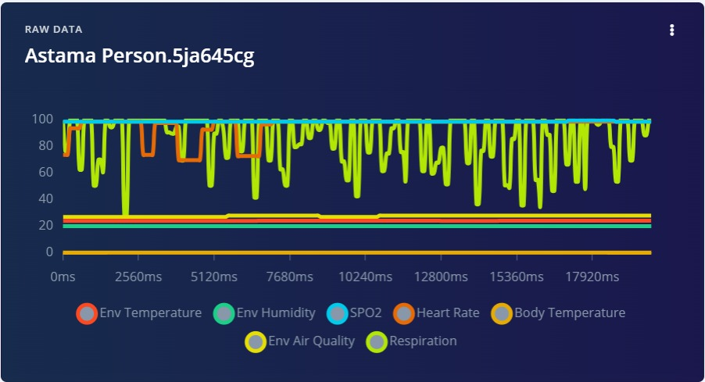

Fig. Pre Asthma warning signs

Fig the provided graph represents physiological and environmental parameter readings for an individual in a pre-asthma warning state. Compared to the normal condition graph, this chart shows notable irregularities, particularly in respiration (yellow-green line), which exhibits more frequent and deeper fluctuations, suggesting unstable breathing patterns. Additionally, SPO2 (cyan line) appears mostly stable but with occasional minor drops, which could indicate slight oxygen desaturation. Heart rate (orange line) shows intermittent dips, which were not present in the normal condition graph, possibly signaling stress on the cardiovascular system due to breathing difficulties. Environmental parameters such as temperature (red line), humidity (green line), and air quality (yellow line) remain relatively stable, meaning external conditions may not be the primary trigger.

The caption suggests this data represents early warning signs of an impending asthma episode, with the erratic respiration pattern and periodic drops in heart rate and oxygen levels as potential indicators. The more pronounced fluctuations in respiration compared to the normal condition graph suggest increasing breathing effort, which could be an early sign of airway constriction or inflammation. This kind of monitoring can be crucial in asthma management, as it allows for early detection and timely intervention before a full-blown asthma attack occurs.

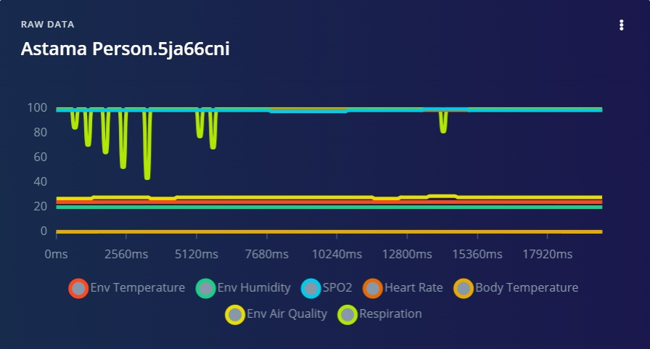

Fig When Asthma is detected

Fig the provided graph represents physiological and environmental readings when asthma is detected. Compared to the previous graphs, this one show significant abnormalities, particularly in the respiration pattern (yellow-green line), which exhibits severe fluctuations with extended drops close to zero. This suggests that the individual is experiencing irregular or obstructed breathing, a hallmark of an asthma attack. Additionally, the SPO2 level (cyan line) remains stable for most of the duration but has a few sharp drops, which could indicate temporary oxygen deprivation due to airway constriction. The heart rate (orange line) appears much more stable compared to the pre-asthma stage, possibly due to the body's reduced ability to compensate for the breathing difficulties.

A notable difference in this graph is the reduced variability in respiration, with more instances of prolonged low levels, suggesting significant difficulty in maintaining normal airflow. This could mean the onset of bronchospasms or airway inflammation, which restricts oxygen intake. Unlike the pre-asthma warning stage, where heart rate exhibited fluctuations, the relative stability here could indicate either a physiological response to distress or a critical state where the body can no longer compensate effectively. The environmental parameters (temperature, humidity, and air quality) remain stable, indicating that external factors might not be the immediate trigger, though they could have contributed earlier.

This data highlights the importance of continuous monitoring in asthma management. The drastic changes in respiration and occasional SPO2 drops suggest that the patient is in an active asthma episode, requiring immediate intervention such as bronchodilators or medical attention. The transition from normal to pre-asthma to detected asthma, as seen in the different graphs, demonstrates how real-time data analysis can provide early warnings and help prevent severe attacks. This kind of monitoring system can be invaluable for individuals with asthma, allowing for proactive management and reducing emergency situations.

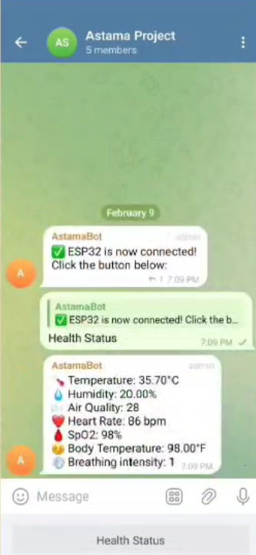

Fig Telegram bot interfaced with

Fig represents telegram bot for real-time health monitoring using ESP32 allows users to check key vitals instantly. Based on the screenshot, the bot provides real-time updates on body temperature, heart rate, SPO2 levels, humidity, air quality, and breathing intensity. This kind of system is particularly useful for monitoring asthma patients or individuals with respiratory issues, enabling quick responses in case of abnormalities.

The approach combines IoT and cloud-based communication, where the ESP32 collects sensor data and sends it to Telegram via a bot. This allows for remote health tracking, reducing the need for constant manual checks. If integrated with alerts for critical values (such as dropping SPO2 or increasing breathing intensity), it can serve as an early warning system for health deterioration. This project showcases how IoT and messaging platforms can be effectively combined to improve health monitoring and emergency response systems.

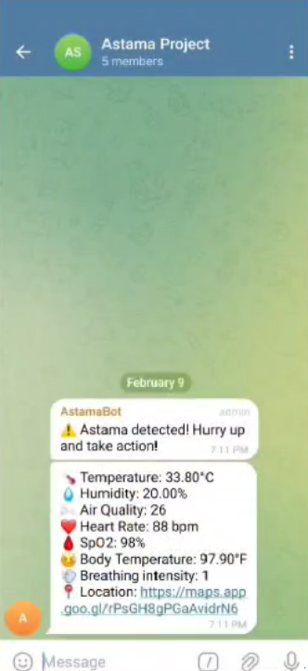

Fig Asthma Detected

Fig represents asthma detection system using ESP32 and a Telegram bot provides real-time health monitoring and emergency alerts. When the system detects asthma symptoms based on predefined thresholds for air quality, humidity, breathing intensity, heart rate, and SPO2 levels, the Telegram bot immediately sends a warning message to notify the user and their caregivers. This instant alert ensures that timely action can be taken to prevent the situation from worsening.

A key feature of this system is live location tracking, which is particularly crucial in emergencies. The bot sends a Google Maps link with the patient’s location, enabling caregivers or emergency responders to quickly locate and assist the individual. This IoT-integrated health alert system is a powerful tool for managing asthma attacks, improving response times, and enhancing patient safety. Future enhancements could include machine learning algorithms to predict asthma episodes in advance and provide proactive medical guidance.

.

# 

# 

# Chapter 4

## Conclusions and future scope

### CHAPTER 4

###### CONCLUSION AND FUTURE SCOPE

###### Conclusion

This project demonstrated the feasibility and potential of a sensor-driven asthma detection system enhanced by machine learning for real-time health monitoring. By integrating multiple sensors and leveraging an Edge Impulse machine learning model trained on physiological and environmental data, the system effectively classified asthma risk levels with high accuracy and reliability. The use of IoT technology and cost-efficient sensor modules makes this solution not only reliable but also portable and affordable, particularly suited for continuous asthma monitoring in resource-constrained settings. This affordability ensures that individuals in low-income regions can access advanced healthcare technologies, bridging the gap between rural and urban healthcare services.

The inclusion of a MEMS microphone for respiratory sound analysis, combined with real-time data processing via an RTOS-enabled ESP32 microcontroller, underscores the system’s advanced capabilities and potential for widespread adoption in diverse healthcare environments. The system’s modular architecture allows for easy customization and scalability, making it adaptable to various patient needs and healthcare settings. Furthermore, the integration of wireless communication technologies facilitates seamless data sharing with healthcare providers, enabling remote monitoring and timely medical interventions. This project lays the groundwork for future innovations in respiratory health monitoring, offering a comprehensive, user-friendly, and effective tool for asthma management and early detection.

###### Future Scope

#### Future advancements could include the integration of genetic and lifestyle data for a more personalized assessment, improving the generalizability of the machine learning model to a broader population, and further enhancing accuracy. By incorporating genomic data, the system could identify genetic predispositions to asthma, allowing for more targeted interventions and personalized treatment plans. Additionally, the inclusion of lifestyle factors such as physical activity, diet, and exposure to allergens would enable a comprehensive understanding of individual health profiles, leading to more precise predictions and management strategies.

#### The development of a companion mobile application for real-time alerts, detailed analytics, and remote healthcare provider access could significantly enhance its utility, making it an indispensable tool for proactive asthma management and improved patient outcomes. This mobile app could offer features such as medication reminders, symptom tracking, and integration with wearable devices for continuous monitoring, empowering patients to take an active role in managing their condition. Furthermore, real-time data sharing with healthcare providers would facilitate timely interventions and personalized care adjustments, improving overall treatment efficacy.

#### Integration with cloud platforms could facilitate large-scale data analysis and longitudinal health tracking, contributing to a deeper understanding of asthma patterns and enabling predictive healthcare. Cloud-based storage and processing would allow for seamless data aggregation from multiple sources, supporting advanced analytics and machine learning model refinement. This approach would also enable cross-population studies, identifying trends and risk factors on a broader scale, and informing public health policies and preventive measures.

#### Moreover, partnerships with healthcare institutions and continuous feedback from clinical trials could help refine the system, ensuring it meets medical standards and user needs effectively. Collaborations with academic and research institutions would foster innovation and the development of new diagnostic algorithms, while clinical trials would provide critical validation of the system's accuracy and reliability. Engaging with patient communities and advocacy groups could also offer valuable insights into user experiences and needs, driving further improvements and ensuring the system remains patient-centric and accessible to diverse populations.

#### BIBLIOGRAPHY

1. Futurity, Lung inflammation in patients with asthma, 2021 (accessed March, 2021), <https://www.futurity.org/device-predicts-Asthma-attacks> 1436782/.
2. D. Rav`ı, C. Wong, F. Deligianni, M. Berthelot, J. Andreu-Perez, B. Lo, and G.-Z. Yang, “Deep learning for health informatics,” IEEE Journal of Biomedical and Health Informatics, vol. 21, no. 1, pp. 4–21, 2017.
3. G. Harerimana, B. Jang, J. W. Kim, and H. K. Park, “Health big data analytics: A technology survey,” IEEE Access, vol. 6, pp. 65661–65678, 2018.
4. Y. Cheng, F. Wang, P. Zhang, and J. Hu, “Risk prediction with electronic health records: A deep learning approach,” in Proceedings of the 2016 SIAM International Conference on Data Mining. SIAM, 2016, pp. 432440.
5. T.R.Gadekallu, N. Khare, S. Bhattacharya, S. Singh, P. K. R. Maddikunta, and G. Srivastava, “Deep neural networks to predict diabetic retinopathy,” Journal Of Ambient Intelligence and Humanized Computing, pp. 1–14, 2020.
6. A. Ben-Cohen, I. Diamant, E. Klang, M. Amitai, and H. Greenspan, “Fully convolutional network for liver segmentation and lesions detection,” in Deep learning and data labeling for medical applications. Springer, 2016,pp. 77–85.
7. J. Y. Choi, H. K. Yoon, J. H. Lee, K. H. Yoo, B. Y. Kim, H. W. Bae, Y. K. Kim, and C. K. Rhee, “Nationwide pulmonary function test rates in south korean asthma patients,” Journal of thoracic disease, vol. 10, no.7, p. 4360,2018.
8. K. M. Gulla and S. Kabra, “Peak expiratory flow rate as a monitoring tool in asthma,” The Indian Journal of Pediatrics, vol. 84, no. 8, pp. 573–574,2017.
9. S.-W. Fu, Y. Tsao, X. Lu, and H. Kawai, “Raw waveform-based speech enhancement by fully convolutional networks,” in 2017 Asia-Pacific Signal and Information Processing Association Annual Summit and Conference(APSIPA ASC). IEEE, 2017, pp. 006–012.
10. D. P. Kingma and J. Ba, “Adam: A method for stochastic optimization,”arXiv preprint arXiv:1412.6980, 2014.
11. Open weather map, Weather Data, 2021 (accessed March, 2021), open-weather map (2020)<https://openweathermap.org/api>.
12. Ngrok, real-time web UI, 2021 (accessed March, 2021), ngrok (2020)
13. C. Tan, F. Sun, T. Kong, W. Zhang, C. Yang, and C. Liu, “A survey on deep transfer learning,” in international conference on artificial neural networks. Springer, 2018, pp. 270–279.
14. G. S. Bhat, N. Shankar, C. K. Reddy, and I. M. Panahi, “A real-time convolutional neural network based speech enhancement for hearing impaired listeners using smartphone,” IEEE Access, vol. 7, pp. 78421–78433,2019
15.  H. Tibble, A. Tsanas, E. Horne, R. Horne, M. Mizani, C. R. Simpson,and A. Sheikh, “Predicting asthma attacks in primary care: protocol for developing a machine learning-based prediction model,” BMJ open, vol. 9, no. 7, p. e028375, 2019.